**Dental Clinic Services System**

Project Proposal

By

**Kanokwan Maneerat 542115002**

**Worapun Wongkium 542115055**

Department of Software Engineering

College of Arts, Media, and Technology

Chiang Mai University

Project Adviser

______________________________

Mrs. Yunrim Park

**Chapter One**

**Project Proposal**

|  |  |  |  |  |  |
| --- | --- | --- | --- | --- | --- |
| **Document Name** | **Detail** | **Status** | **Date** | **Viewable** | **Reviewer& Responsible** |
| Our Senior Project(542115002,542115055) | Scope and overview of project | Draft | 1/13/2014 | Adviser | Kanokwan& Worrapun |
| SeniorProject_Agent P_09022014 | Cover all project proposal | Release | 2/9/2014 | Adviser | Kanokwan& Worrapun |
| SeniorProject_Agent P_28022014-v 1.5 | Edit all wrong English, milestone and all part of project proposal. | Release | 2/28/2014 | Adviser | Kanokwan& Worrapun |
| SeniorProject_Agent P_03022014-v 1.7 | Edit all wrong English,and using more clear words | Draft | 3/3/2014 | Adviser | Kanokwan& Worrapun |
| SeniorProject_Agent P_04032014-v 1.8 | Change milestone, double check English, and add cover page | Draft | 4/3/2014 | Adviser | Kanokwan& Worrapun |

**Chapter One: Introduction and Background**

The dental clinic is one of the important parts of our life. All of people have to go to the dental clinic when they get some problem with their teeth such as toothache, gum ache or teeth braces. It is like when we go to the hospital, but for the dental clinic it treats only problems with the teeth. In one, a clinic has many patients and many cases for treating. One of the common cases, for example, is the teeth braces which often require a long term treatment, possibly up to 4 years. The patient who has teeth braces has to make an appointment with the dentist around once a month.

The problem is patients often lose their appointment card and forget the appointment date, which may affect their health. They will have some trouble with their teeth, which sometimes can be very dangerous. In some cases, patients want to change their appointment date. They do not know exactly when the dentist is free because the dentist has his/her own schedule which contains all of the patient appointments. Besides the problems with appointments, patients may also want to know the total cost of their case.

To solve these problems, “The dental clinic website and mobile application” provides functions for patients, visitors, officers and dentists. For visitors who are interested in dental treatments, the website and mobile application provides information about dental treatment and estimated cost. Visitors can also interact with the dentist on the web. Visitors can consult with the dentist about some problem they are experiencing. This website and mobile application includes dentists schedule and also the appointment feature which allows visitors to make an appointment with a dentist online. For patients, the website and mobile application contains the reminder function for reminding them of upcoming appointments so that they do not miss the appointments. The same feature also sends out a notification when the schedule changes. It will notify about the appointment 1-2 days before the appointment date. The dental clinic website and application can also generate the QR code for each patient, which can be used to identify the patient and his/her appointment at the clinic. This streamlines the process of receiving patients and looking up appointments. At the same time, it relieves the problems of patients losing or forgetting to bring their appointment cards.

.

**Chapter Two: Literature Review**

**2.1 Business review**

**2.1.1 Dental Clinic Services System**

Dental Clinic Service System is a system that provides services to customers of Dental Clinic(patients) such as dentist’s schedule, managing appointments and reminders, promotions, dental clinic’s information, consulting and follow up between a dentist and a patient. Customers can access both the web application and mobile application. At the dental clinic, officers can manage dentist’s schedule, add advertisements, and identify patients with QR code. Dentists can interact with customers through both applications, such as giving consultation and following up their patients.

Examples of dental website and mobile application are shown below.

**2.1.1.1 Dental Clinic by Cosmetic Innovations, Inc**.

Dental Clinic is a patient’s guide to understanding all aspects of dentistry and its procedures. This application includes the most frequently asked dental questions answered by the top dental experts in each field, and overseen by NYC Cosmetic & General Dentist - Dr. Marc Lazare. This app includes:

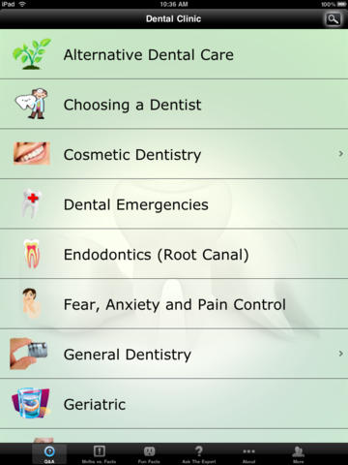

Figure 1: Show all menu that customers can use.

As shown in Figure 1, when users open the application, they can see all of these menu items that they can select to see information.

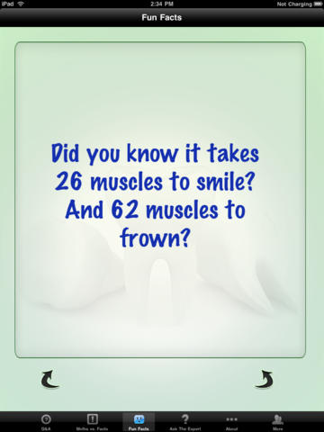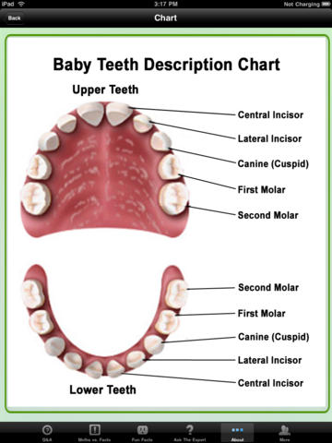

Figure 2: Show users interface after they select some menu

As shown in Figure 2, users can select to see the useful information such as ‘Best ways to minimize your pain, fear and anxiety’ • ‘All of the important information you should know about your children’s dental care’ • ‘Knowing what all of your options are when missing one or more teeth’ • ‘What you should know about teeth whitening’.

### 

### 2.1.1.2 Dr.Sunil Dental Clinic - Cosmetic, Oral & Implant Dentistry

The website for Dental Center in Bangkok which provides foreign customers with advertisement of the clinic including the information about the services provided to customers. Customers can fill the document form to make an appointment. Customers also can use the provided QR code to call, email, and visit the website of dental clinic. But this website is only for customers and has only some information of dental care. Dentists cannot interact with customers directly.

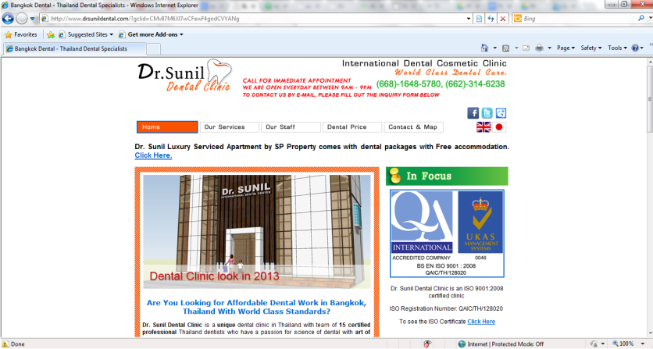

### 

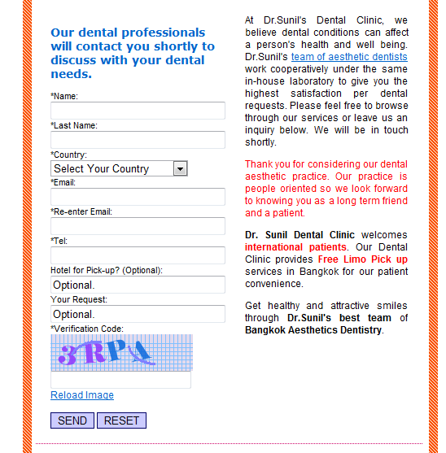Figure 3: Show website of Dr.Sunil Dental Center

Figure 4: Show the contact with Dr. Sunil

As shown in Figure 4, customers can send their information to Dr. Sunil and wait for email to get an appointment.

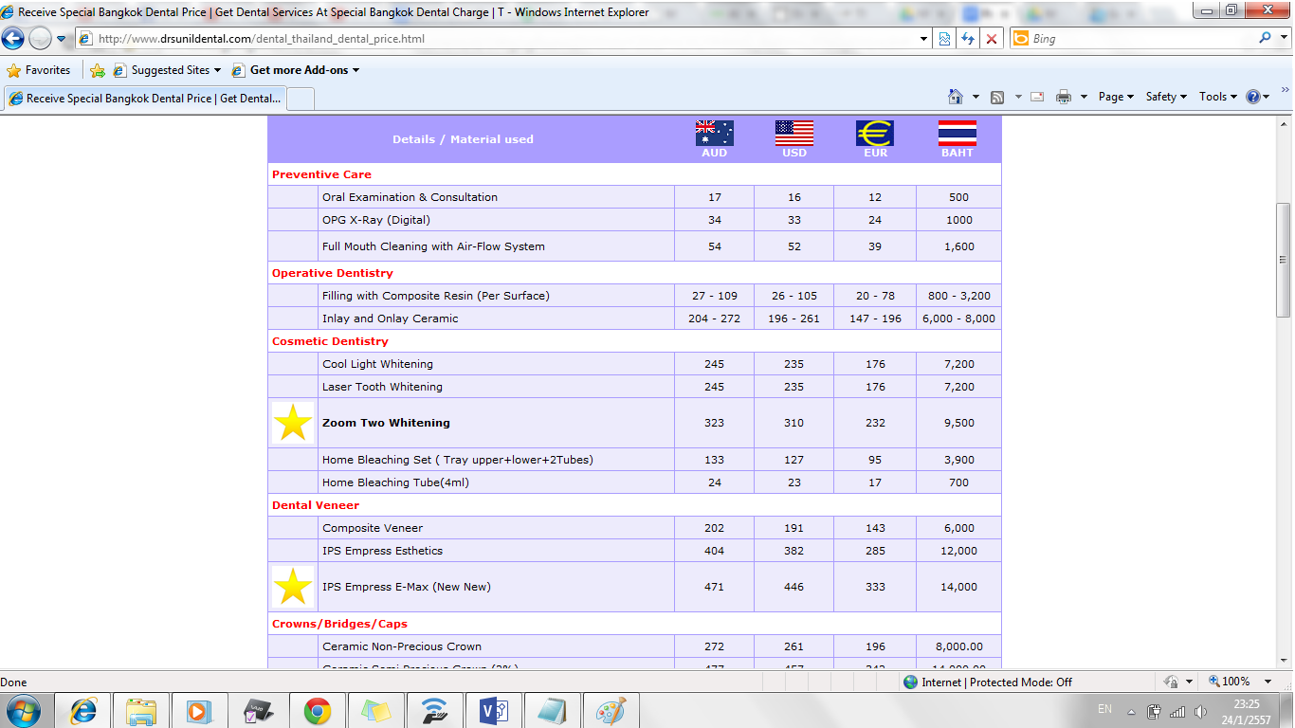

Figure 5: Show the price rate

As shown in Figure 4, customers can see the cost that they have to pay for each treatment.

**2.2 Technology Review**

**2.2.1 QR code**

**2.2.1.1 QR code**

QR code (quick response code) is a type of [2D barcode](http://searchmobilecomputing.techtarget.com/definition/2D-barcode) that is used to provide easy access to information through a [smartphone](http://searchmobilecomputing.techtarget.com/definition/smartphone).

In this process, known as mobile tagging, the smartphone’s owner points the phone at a QR code and opens a [barcode reader](http://whatis.techtarget.com/definition/barcode-reader-POS-scanner-bar-code-reader-price-scanner) app which works in conjunction with the phone’s camera or a webcam. The reader interprets the code, which typically contains a call to action such as an invitation to download a mobile application, a link to view a video or an [SMS](http://searchmobilecomputing.techtarget.com/definition/Short-Message-Service) message inviting the viewer to respond to a poll. The phone’s owner can choose to act upon the call to action or click cancel and ignore the invitation. The QR code can recognize the URL website. Normally the URL website is difficult to keep because it’s too long and some of it is too complex. For QR code just scanning an item with a QR code provides a link to the website of that item.[1]

**2.2.1.2 Zxing**

Zxing or Zebra Crossing is a library for generating and detecting QR code. The library is being developed by Google with many other contributors. In iPhone, Zxing can work better than other QR Code libraries.[2]

**2.2.1.2 Alternative Technology**

QR code is quite similar to 2D barcode and RFID (Radio-frequency identification). Both of them contain information and can using the information easier and faster. A barcode is normally used more than QR code and RFID because it is easier to encode and decode and also the cost is cheaper.

**2.2.1.3 The selection of this technology**

The reason why we choose QR code technology is because it is now very popular and most people use a smartphone. It is easy to use and comfortable. Using a QR code for identification, patients do not need to bring their appointment card when they come to the clinic. And another reason for using QR code is that is it faster and more reliable than using appointment card. We use Zxing to generate QR code to identify patients and their appointments.

**2.2.2 PhoneGap**

**2.2.2.1 PhoneGap**

PhoneGap is an application framework that enables us to develop Mobile Application easier and build natively installed applications using HTML, HTML5 and JavaScript. Phone Gap is a Hybrid Application for Mobile. We can build user interface using traditional web development methods and skills, and use the PhoneGap container to deploy applications to different operating systems including Apple iOS, Google Android, Windows Phone, BlackBerry, HP WebOS, Symbian, and Bada.[3]. And they can be distributed via popular application market places (i.e. iTunes, Google App Market, Amazon Market, etc.)

**2.2.2.2 Alternative Technology**

Xcode and Titanium are integrated development environments (IDEs) that help create mobile applications which can be used on smartphones and tablets. Xcode includes a suite of development tools to build iOS mobile applications directly, while Titanium can create applications for many platforms, similarly to Phone Gap. It supports iOS, Android, and etc. The programming languages supported are JavaScript, HTML, CSS, Python, Ruby, and PHP.

**2.2.2.3 The selection of this technology**

For choosing PhoneGap to develop the application because it is an open source. We will create the mobile application by using HTML5, CSS, and JavaScript, all of which are supported by PhoneGap. And it can support 7 kinds of operating systems including iOS which is the mobile platform we have chosen for this project. PhoneGap will wrap the website to be the application. It contains the features that we have to use for this project such as camera function or database.

**2.2.3 HTML5**

**2.2.3.1 HTML5**

HTML5 is markup language used for creating websites. Evolved from the HTML standard, HTML5 has more features such as working with MAP system, and creating a graphic without flash. And HTML5 is supported by many operating systems on various devices such as Windows PC, MAC, iPhone, iPad, and Android-based mobile phones and tablets. It works with CSS and JavaScript and can be used not only to develop for the World Wide Web also but also to create mobile applications.

**2.2.3.2 Alternative Technology**

-

**2.2.3.3 The selection of this technology**

HTML5 has been selected for this project because it is the newest version of the HTML and supported by PhoneGap along with CSS and JavaScript. It can be used to develop both the dental clinic website and the mobile application of dental clinic.

**2.2.4** MySQL Server

**2.2.4.1 MySQL** Server

## MySQL Server is a Rational Database Management System(RDBMS) that stores data in separate tables. MySQL Server is an open source database that can be used in many different platforms and is very fast, reliable, scalable, and easy to use. It also provides a high performance, multi-threading, and multiuser rational database management. [4]

**2.2.4.2 Alternative Technology**

## SQLite is an self-contained in-process library of SQL database engine. To use SQLite, users do not need to install it, nor set up the SQLite Server. It runs on many operating systems such as OSX, Windows, Linux or Android. [[5]](http://www.sqlite.org/famous.html)

**2.2.4.3 The selection of this technology**

The dental clinic system needs to store and maintain patients’ information as well as the information of treatments and others. All data need to be stored in a database that enables secure and stable management of the information. MySQL Server has been selected for this project because the database of dental clinic can potentially handle a large amount of data. SQLite is more suitable for a system that contains a small amount of data and has a limited storage.

**2.2.5 Apache web server**

**2.2.5.1 Apache web server**

Apache is a [public-domain](http://www.webopedia.com/TERM/P/public_domain_software.html) [open source](http://www.webopedia.com/TERM/O/open_source.html) [Web server](http://www.webopedia.com/TERM/W/Web_server.html) which provide a web page through the HTTP protocol. It is support in every operating system, including [Unix](http://en.wikipedia.org/wiki/Unix" \o "Unix), [FreeBSD](http://en.wikipedia.org/wiki/FreeBSD" \o "FreeBSD), [Linux](http://en.wikipedia.org/wiki/Linux" \o "Linux), [Solaris](http://en.wikipedia.org/wiki/Solaris_%28operating_system%29" \o "Solaris (operating system)), [Novell NetWare](http://en.wikipedia.org/wiki/Novell_NetWare" \o "Novell NetWare), [OS X](http://en.wikipedia.org/wiki/OS_X" \o "OS X), [Microsoft Windows](http://en.wikipedia.org/wiki/Microsoft_Windows" \o "Microsoft Windows), [OS/2](http://en.wikipedia.org/wiki/OS/2" \o "OS/2), [TPF](http://en.wikipedia.org/wiki/Transaction_Processing_Facility" \o "Transaction Processing Facility), [OpenVMS](http://en.wikipedia.org/wiki/OpenVMS" \o "OpenVMS) and [eComStation](http://en.wikipedia.org/wiki/EComStation" \o "EComStation).

**2.2.5.2 Alternative Technology**

Tomcat is Servlet/JSP Container, which is in the Apache open source project. Tomcat is a web server can cooperate with jsp language. It supports to create a website or web server by using jsp language.

**2.2.5.3 The selection of this technology**

The dental clinic service system is a web application. Therefore, an apache will support the website for using on the network. It supports many programming languages such as PHP, MySQL database. Client can open the web browser to enter to the website by input the name as url. The dental clinic can distribute the information in the world wide.

**2.2.6 Architecture**

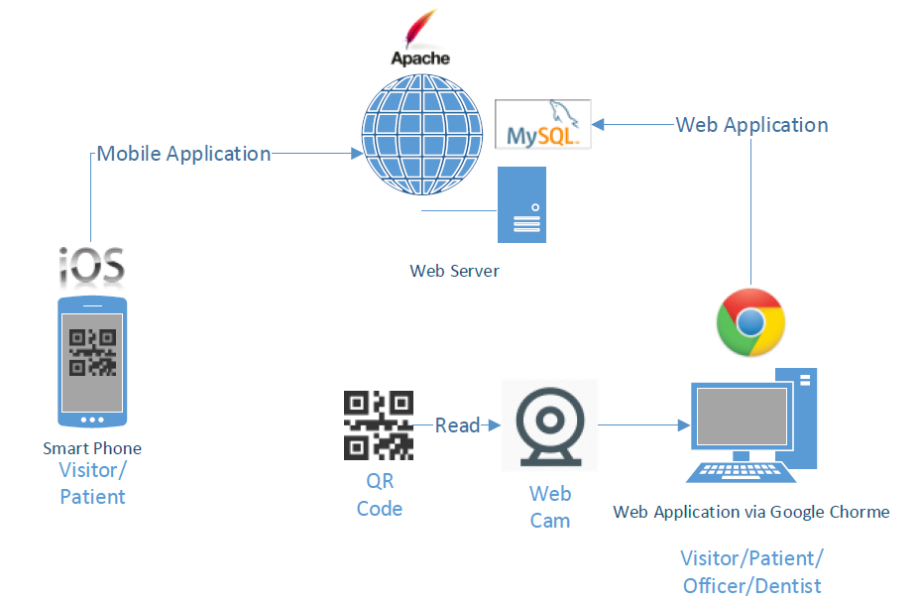

Figure 6: System Architecture

As shown in Figure 6, visitors and patients can use both the mobile application and the web application. Officers can use the web application to manage the schedule, add information via the Google Chrome browser, and identify patients by scanning QR code using a webcam. Dentists can manage their schedule and provide consultation to their patients using the web application. The system generates QR code for the patients and send it to their smartphone. The database of system is stored on the web server.

**Chapter Three : Quality Standard**

**3.1 ISO29110 for Very Small Entity(VSE)**

ISO29110 is a guide applies to a Very Small Entity (SVE), enterprise, organisation, department or project up to 25 people, dedicate to software development. The Guide provides Project Management and Software Implementation process which integrate practices based on the selection of ISO/IEC 12207- System and Software Engineering - Software Life Cycle Processes and ISO/IEC 15289 Software Engineering - Software Life Cycle Process - guidelines for the content of software life cycle process information products(documentation) standard elements.

**3.1.1 Project Management Process**

The propose of the Project Management process is to establish and carry out in a systematic way the task of the software implementation project, which allows complying with the project’s objectives in the expected quality, time and cost.

**Selected process**

3.1.1.1 Project Planing Process

3.1.1.2 Project Plan Excution Process

3.1.1.3 Project Plan Assesment and Control Process

3.1.1.4 Project Closer Process

**3.1.2 Software Implementation process**

The purpose of the Software Implementation process is the systematic performance of the analysis, design, construction, integration and tests activities for new or modified software products according to the specified requirements.

**Selected process**

3.1.2.1 Software Implementation Initiation Process

3.1.2.2 Software Requirements Analysis Process

3.1.2.3 Software Architectural Design Process

3.1.2.4 Software Construction Process

3.1.2.5 Software Integration and Test Process

3.1.2.6 Software Delivery Process

**Chapter Four : Project Plan**

**4.1 Motivation**

Nowadays people in Thailand are more interested in dental care, and the number of dental clinics is increasing very fast, each with different number of patients. Dental clinics need to handle many patients and also many problems. Some of the typical examples are; patients forget about their appointment, patients do not have any knowledge about dental care, patients do not know the dentist schedule. Systems dedicated to serving dental care providers and patients will help solve these problems.

According to a recent research about mobile phone use, the number of smartphone users in 2013 increased by 29.1 percent from 2012 [6] and the number of people using mobile internet increased by 32 percent in 2013 [7]. People always use their phone to do many things such as entertainment, booking, shopping, communicating with others, accounting, and marketing.

In addition, such systems for dental clinics may improve the quality of services provided to their patients. For instance, most dental clinics rely on appointment cards to receive patients and keep track of their appointments. When patients arrive at the dental clinic, they have to provide their appointment card at the reception desk and the officer would have to look up the patient chart, which usually takes time. By integrating smartphones and QR codes into the workflow, our system can identify appointments faster and reduce the work of officer. For the Dental Clinic Services System, QR codes are more suitable than barcodes because they can be stored in and read from smartphones as well as traditional paper-based cards.

**4.2 Aim and Objective**

The aim of this project is to develop a website and a mobile application that can help patients make appointments with dentists more easily and manage their appointments more efficiently. The system should support the management of the appointment schedule for both dentists and patients, remind patients about an upcoming appointment, provide dentists schedule to the visitors who want to make an appointment, reduce the time and work of dental clinic officers. The system will make sure that each patient has an appointment, gets proper consult from a dentist and also provide useful knowledge about dental treatment and dental care.

Objectives

1. Appointment management
2. Schedule sharing
3. Online consultation
4. Cost estimation
5. Advertisement and promotion
6. Knowledge of dental care
7. Patient identification

**4.4 Deliverables and Limits**

**4.4.1 Deliverables**

The dental clinic system, the final product will consist of

* 4.4.1.1 **Software systemWeb application**
* The web application support for sending an appointment information, generating a QR code for each appointment, and authentication and authorizing patients by reading QR code using webcam.The dental web application that supports dental clinics which have many patients and solve the patients’ problems discussed in 4.1
* **Mobile application**

The dental mobile application for smartphones on the IOS operating system that supports dental clinics which have many patients and solve the patients’ problems discussed in 4.1

**Documentation**

• Project Proposal

• Project Plan

• Software Requirement Specification

• Software Design Document

• Testing Documents

-- Test Plan

-- Unit Test Document

-- System Test Document

• Traceability Record

**4.4.2 Limits**

- The web application can run on Google Chrome only.

- Mobile devices (smartphones should use the iOS7 or newer version for better performance in application.

- Mobile devices (smartphones) should support Edge, Wi-Fi ,or 3G.

- Internet connection is required.

Without Internet Access, users cannot receive QR codes, and dentist’s schedule from the clinic. *(QR code contains a patient information)

- Without internet connection, the mobile application provides the clinic’s information, dental care’s knowledge, promotion, and cost of dental care only.

**4.5 Future work**

- Support other major operating system platforms, for example; Android and Windows Mobile.

- Use other technologies to provide more convenient services to clinic officers and customers. For example, sing RFID, officers will not need to use a camera to scan QR code but can just use RFID to verify the patient.

**4.6 Schedule and Milestone**

This section presents the schedule and milestones that cover all the activities to be undertaken in the project. According to the current plan, the project will be completed by September, 2014.

**Progress 1**

* Feature1: Provide dentist’s schedule to manage
* Feature2: Appointment reminder.

**Progress 2**

* Feature3: A dental clinic information, promotion, and cost of dental care.
* Feature4: Identify patient by QR code.
* **Progress 3**Feature5: Dental care consulting and following up.

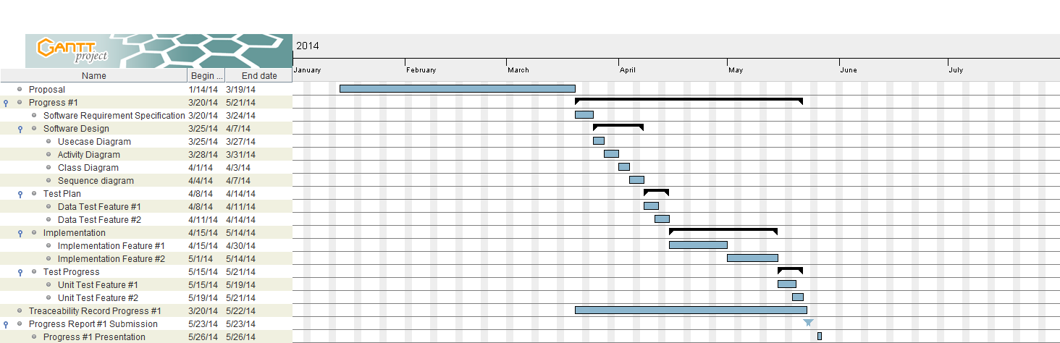

Figure 7: Milestone of Proposal and Progress 1

As a figure 7 the proposal stage starts around January until middle of March. Progress 1 start around middle March until middle May

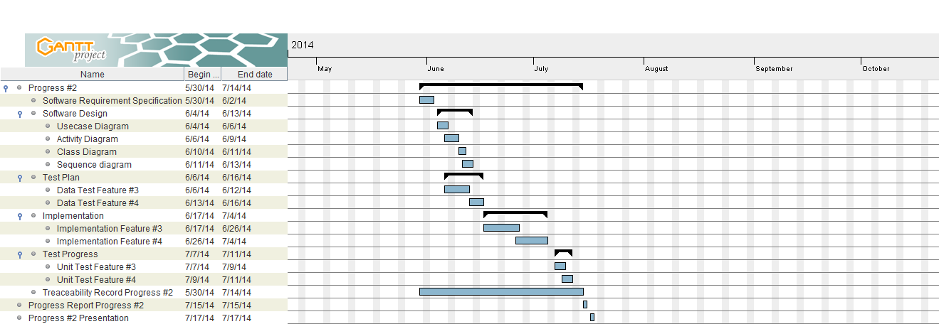

Figure 8: Milestone of Progress 2

As a figure 8 progress start around middle May until middle July.

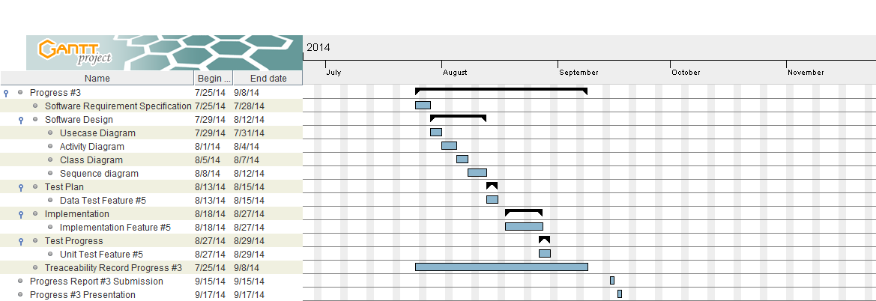

Figure 9: Milestone of Progress 3

As a figure 8 progress start around middle August until middle September.

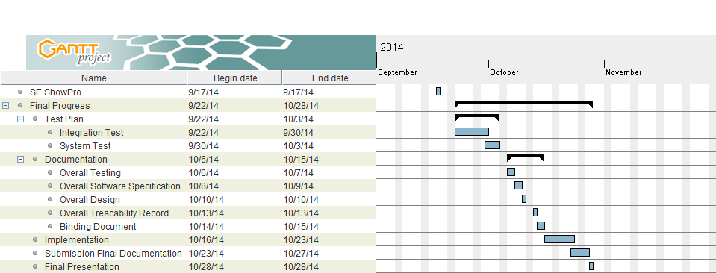

Figure 10: Milestone of SE ShowPro and Final Progress

As a figure 10 SE ShowPro is around middle September. Final progress is around middle September until middle November.

**Chapter five : References**

[1]: [**Marc Lyne**](http://searchengineland.com/author/marc-lyne)**,“**[**What Is A QR Code And Why Do You Need One?**](http://searchengineland.com/what-is-a-qr-code-and-why-do-you-need-one-27588)**”**

<http://searchengineland.com/what-is-a-qr-code-and-why-do-you-need-one-27588>

[2]: [**Gregory Raiz**](http://www.quora.com/Gregory-Raiz)**, “What is the best QR decoder library for the iPhone?”**

<http://www.quora.com/What-is-the-best-QR-decoder-library-for-the-iPhone>

[3]: **PhoneGap, “Supported Features”**

<http://phonegap.com/about/features>

[4]: **MySQL, “What is MySQL?”**

<http://dev.mysql.com/doc/refman/4.1/en/what-is-mysql.html>

[5]: **SQLite, “Docmentation”**

<http://www.sqlite.org/>

[6]: **AtimeDesign, “วงการสมาร์ทโฟนไทยกับเว็บไซต์”**<http://www.atimedesign.com/webdesign/%E0%B8%A7%E0%B8%87%E0%B8%81%E0%B8%B2%E0%B8%A3%E0%B8%AA%E0%B8%A1%E0%B8%B2%E0%B8%A3%E0%B9%8C%E0%B8%97%E0%B9%82%E0%B8%9F%E0%B8%99%E0%B9%84%E0%B8%97%E0%B8%A2%E0%B8%81%E0%B8%B1%E0%B8%9A%E0%B9%80%E0%B8%A7/>

[7]: **thumbsup, “Increased of mobile users push web responsive design”**

http://thumbsup.in.th/2013/04/increase-mobile-users-push-web-responsive-design/